# Exercise 2: Teuschl

SQL database: Find all information about the following properties

### ID, firstname, lastname

### username, password

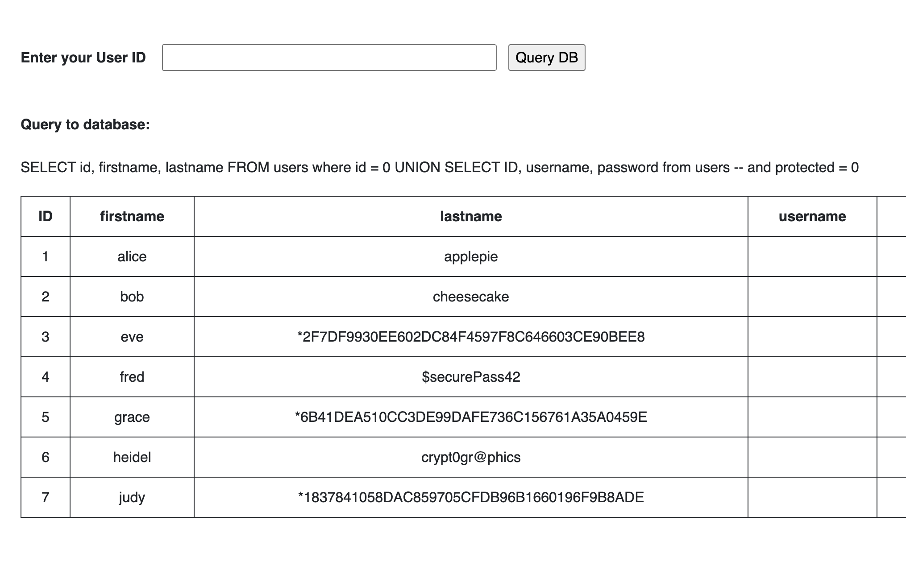

### svnr, protected, license, salery, hobbies

### 

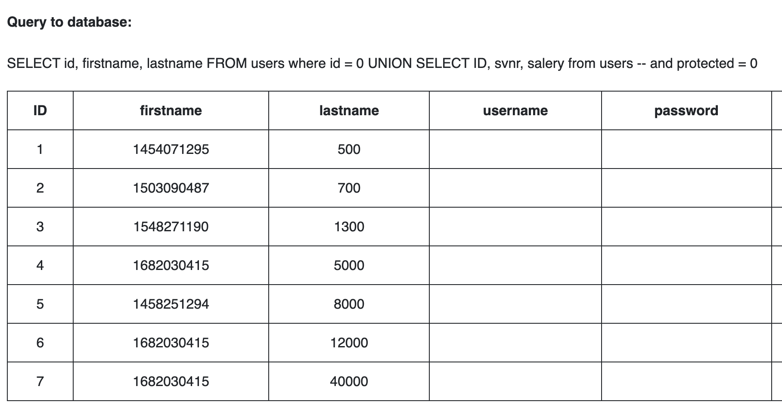  
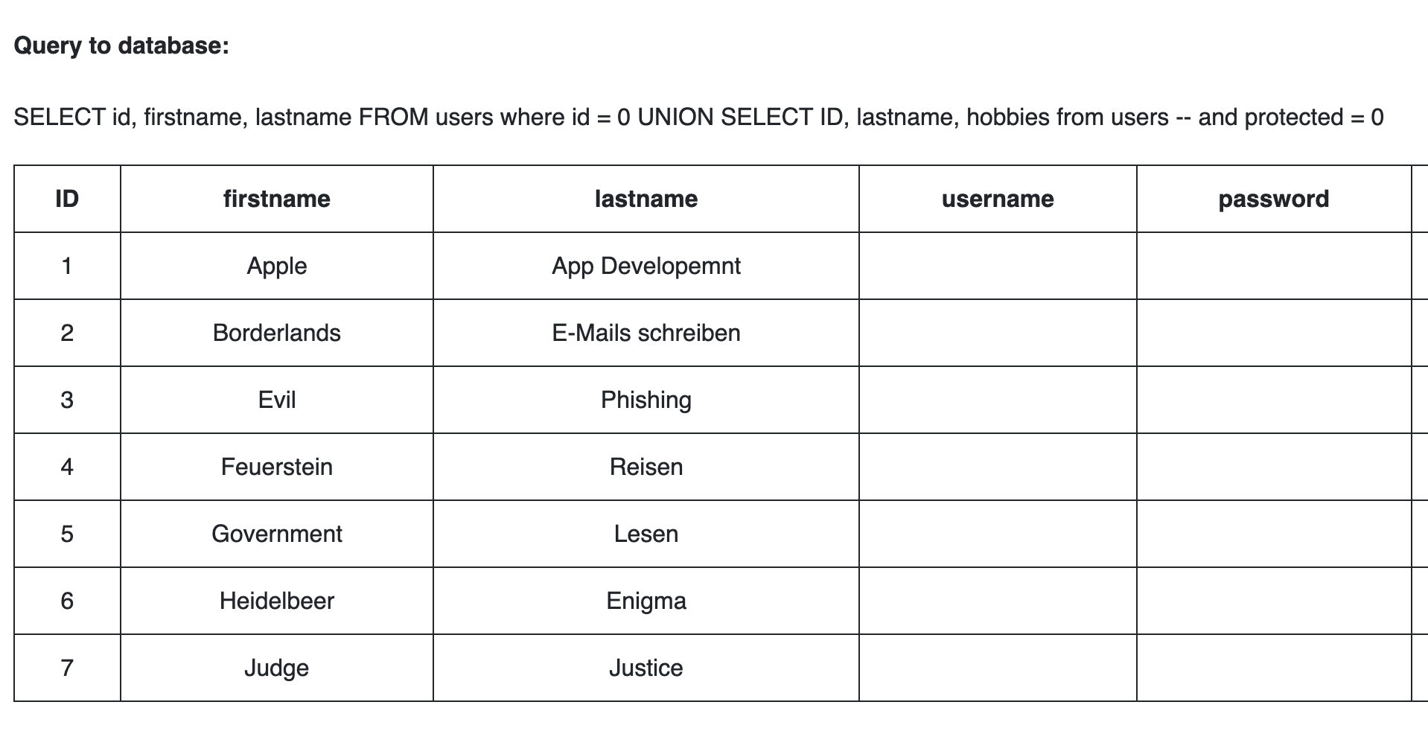

### database version, current user, server version

